Predicting Flight Delays: An Exploration of Advanced Techniques and Implications

Vishesh Saharan

**Introduction:**

The aviation industry plays a vital role in connecting people and goods across the globe. However, one persistent challenge faced by airlines, passengers, and stakeholders is the occurrence of flight delays. Flight delays can disrupt travel plans, cause economic losses, and impact the overall efficiency of the aviation system. Therefore, accurate prediction of flight delays has become a pressing concern for researchers, airlines, and travelers alike.

In recent years, the advancement of machine learning techniques and the availability of vast amounts of historical flight data have opened up new possibilities for predicting flight delays with unprecedented accuracy. By leveraging these technologies, researchers and industry professionals can gain valuable insights into the factors contributing to flight delays, allowing them to develop proactive strategies for reducing delays and improving overall operational efficiency.

In this study, we will explore the underlying factors influencing arrival delay times, considering a multitude of variables, such as weather conditions, air traffic congestion, flight distance, airline operations, and historical performance. By analyzing these factors and their interactions, we aim to identify patterns, correlations, and trends that contribute to the occurrence of delays.

To achieve our research objectives, we will leverage a comprehensive dataset comprising historical flight records, encompassing diverse airlines, origin airports, destination airports, and geographical regions. This dataset will serve as the foundation for training and evaluating predictive models. We will employ a range of advanced machine learning algorithms incorporating three different regression models to develop a model capable of predicting arrival delay times with precision. We will then compare these models through statistical scores to decide which method provided the most robust and accurate model.

The outcomes of this research hold substantial implications for the aviation industry. Airlines can benefit from reliable arrival delay predictions by optimizing flight schedules, crew allocation, and operational decision-making processes. By identifying potential delay-prone routes or time slots, airlines can proactively allocate resources, mitigate delays, and improve their overall on-time performance. Furthermore, passengers can make informed decisions regarding their travel plans, managing their time more effectively and minimizing the impact of potential delays on their itineraries.

The proposed research contributes to the existing body of knowledge by providing a comprehensive analysis of predicting arrival delay times in air travel. By combining advanced machine learning techniques, historical flight data, and a thorough exploration of contributing factors, we aim to develop an accurate and reliable predictive model. The research findings will not only facilitate enhanced operational efficiency within the aviation industry but also contribute to the overall improvement of air travel experiences for passengers.

This research paper seeks to bridge the gap between theoretical knowledge and practical implementation by focusing specifically on predicting arrival delay times between origin and destination airports. Through an in-depth exploration of various factors affecting delays and the utilization of advanced machine learning techniques, we aim to provide valuable insights that empower airlines, passengers, and industry stakeholders to make informed decisions, optimize operations, and enhance the overall efficiency of air travel.

**Dataset:**

The dataset utilized in this research paper was obtained from Kaggle, a popular online platform for data science and machine learning. This data uses the U.S. Department of Transportation's (DOT) Bureau of Transportation Statistics to track the on-time performance of domestic flights operated by large air carriers. The dataset contains a comprehensive collection of flight records with various attributes that are crucial for predicting arrival delay times between origin and destination airports. The dataset encompasses diverse airlines, flight numbers, origin airports, destination airports, and geographical regions.

The following are the main features included in the dataset:

1. FL_DATE: The date of the flight departure (format: YYYY-MM-DD).

2. OP_UNIQUE_CARRIER: A unique identifier for the operating airline.

3. OP_CARRIER_FL_NUM: The flight number assigned by the operating carrier. (format: IATA code *DL,WN,etc).*

4. ORIGIN: The code representing the origin airport(format: IATA code *DTW, SFO, etc)*.

5. DEST: The code representing the destination airport(format: IATA code *DTW, SFO, etc)*.

6. DEP_TIME: The actual departure time (format: HHMM).

7. DEP_DELAY: The departure delay time in minutes (negative values indicate an early departure).

8. TAXI_OUT: The time it takes for an aircraft to depart from the gate to the takeoff runway, in minutes.

9. WHEELS_OFF: The time when the aircraft's wheels leave the ground (format: HHMM).

10. WHEELS_ON: The time when the aircraft's wheels touch the ground at the destination airport (format: HHMM).

11. TAXI_IN: The time it takes for an aircraft to taxi from the landing runway to the gate, in minutes.

12. ARR_TIME: The actual arrival time at the destination airport (format: HHMM).

13. ARR_DELAY: The arrival delay time in minutes (negative values indicate an early arrival).

14. AIR_TIME: The actual flight time in minutes.

15. DISTANCE: The distance traveled by the aircraft in miles.

16. CARRIER_DELAY: The delay time attributed to the air carrier (in minutes).

17. WEATHER_DELAY: The delay time attributed to weather conditions (in minutes).

18. NAS_DELAY: The delay time attributed to the National Aviation System (in minutes).

19. SECURITY_DELAY: The delay time attributed to security-related issues (in minutes).

20. LATE_AIRCRAFT_DELAY: The delay time attributed to a late-arriving aircraft (in minutes).

Data cleaning was performed on this initial dataset in order to achieve the most robust and accurate model as possible. A further discussion will be detailed in the experiment section of the report, where the intentions behind each procedure will be explained how it ties to the specific regression methods used.

**Data Exploration/Visualization:**

In order to assess the cleanliness of the data, an if statement was produced to ensure no ‘NA’ or blank values were found in the clean dataset. A screenshot is provided below:

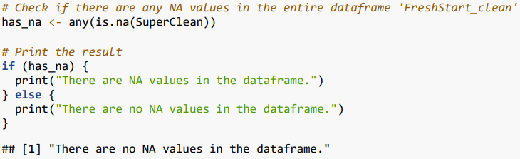

***Figure 1: Demonstration that a clean dataset was used in the study***

To understand our dataset and target variable of ARR_DELAY better, summary statistics were computed on the target variable.

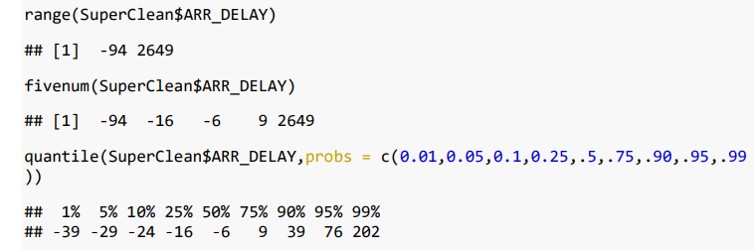

***Figure 2: Summary stats regarding the variable ARR_DELAY in the clean dataset***

To further understand the features of the dataset, graphics such as bar charts, box plots, and scatter plots were employed. A “Q3” function was written to calculate the third quantile of the variable of interest. This function also printed out the median and max of the variable of interest as well. The third quantile is a good summary indicator because it provides insight into the distribution of the variation of the variable of interest. It offers a robust measure that takes into account the bulk of the variable distribution, making it valuable for assessing which variables play a strong role in arrival_delays.

One of these features was the airline carrier with the aim of trying to understand which carriers had the worst and best arrival delays in 2019.

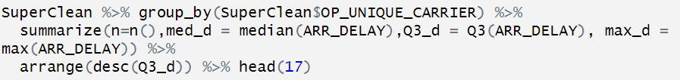

***Figure 3: Q3 function in R for Arrival Delays by major airline carrier in the US***

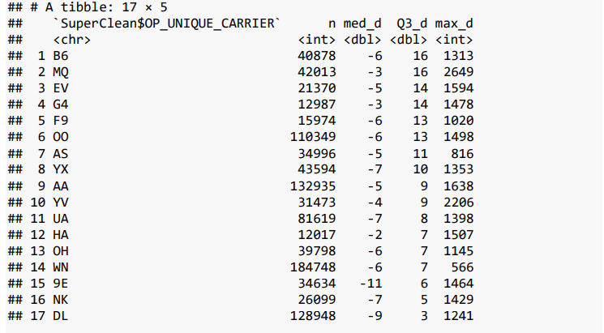

***Figure 4: Arrival Delays by major airline carriers based in the USA by minutes. Ranked by 75th percentile values***

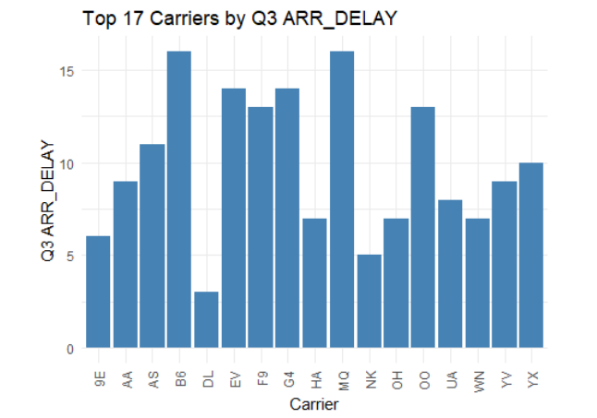

***Figure 5: Bar Plot of Arrival Delays for each major carrier***

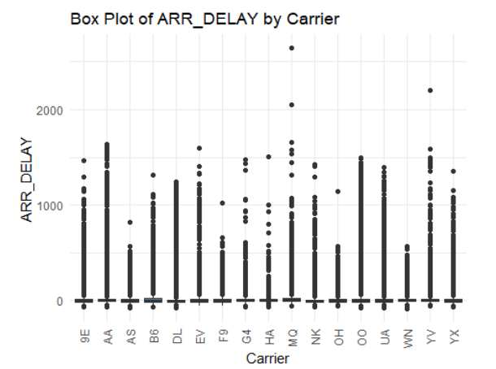

***Figure 6: Box Plot of Arrival Delays for each major carrier***

From Figure 4, Figure 5, and Figure 6 we can see that the worst airlines by arrival delays are B6(JetBlue),MQ(Envoy Air), EV(ExpressJet),G4(Allegiant), and F9(Frontier). We can also see that the best airlines by arrival delays are DL(Delta),NK(Spirit),9E(Endeavor Air),WN(Southwest), and OH(PSA Airlines).

Another variable that was studied was the specific airport and how each airport fares in terms of arrival delays. The Q3 function was applied to all airports in our cleaned dataset. To further understand this factor, a subset of the cleaned data was created to only contain the destination airport of the top 35 busiest airports in the US. Q3 analysis and visualizations were created on this subset. This helped us understand which major airports and geographic regions performed the worst in terms of arrival delays.

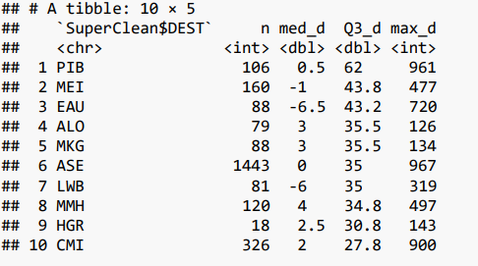

***Figure 7: Airports with most severe arrival delays in minutes . Ranked by 75th percentile values***

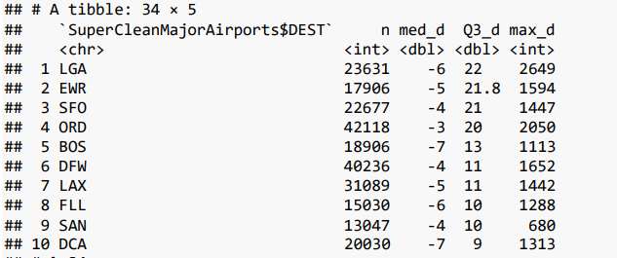

***Figure8: Major airports with most severe arrival delays in minutes . Ranked by 75th percentile values***

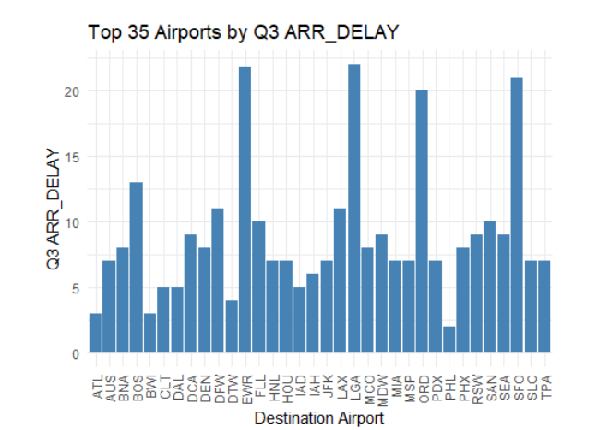

***Figure 9: Bar plot of Major Airports by arrival delays.***

From Figure 7, it is evident that the worst airports in terms of arrival delays were PIB(Hattiesburg, LA),MEI (Meridian, LA), EAU (Eau Claire, WI), ALO (Waterloo, IA), MKG (Muskegon, MI). We can see from Figure 8 and 9 that the worst major airports by arrival delays were LGA(LaGuardia, NYC), EWR(Newark, NJ), SFO (San Francisco, CA), ORD (Chicago, IL), BOS (Boston, MA). We also see that the best airports in terms of arrival delay are PHL (Philadelphia, PA), BWI (Baltimore, MD) , ATL(Atlanta, GA), DTW (Detroit, MI), IAD (Dulles Intl, VA). These results provide valuable insight into which area might experience the worst delay, as we see the New York area appearing twice in the bottom 5 for worst delays. We also experience more delays for smaller Southern and Midwestern airports, but this trend does not apply to major airports in the region, as evidenced by Detroit, Atlanta, and Washington-Dulles showing up as the best airports in terms of delay. There also appears to not be a trend between airport traffic and delays, as Atlanta is not with fellow top 10 busiest airports, Chicago and San Francisco in terms of airports with the worst delays.

Another variable of interest was looking into which dates had the most delays. This would clarify the seasonality of delays. A Q3 function was performed on the flight date from the cleaned dataset.

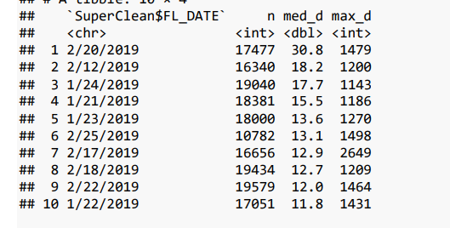

***Figure 10: Top 10 dates in 2019 by arrival delays. Ranked by 75th percentile***

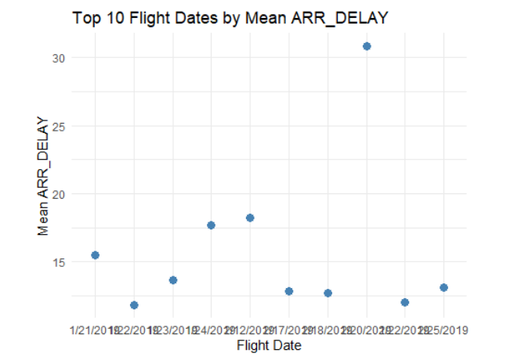

***Figure 11: Scatter plot of flight dates with the most arrival delays***

Figure 10 and 11 demonstrate that most delays fell between January 21st, 2019 and February 22nd, 2019. This would indicate that the winter months of the calendar year might be more linked to arrival delays nationwide

The next set of data exploration involved the target variable directly and correlations between independent variables. A histogram was produced demonstrating the distribution of arrival delays.

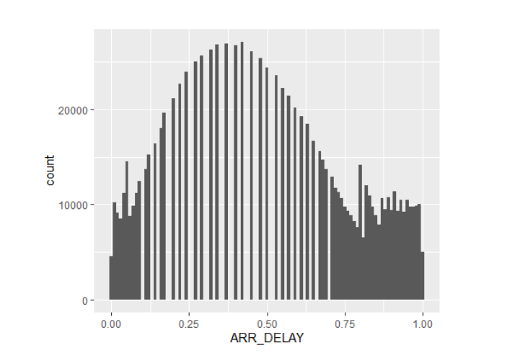

***Figure 12: Histogram displaying the distribution of arrival delays***

From Figure 12, we can see that arrival delays were mostly concentrated to either very short delays, or quite long delays. This is evidenced by the spacing between each histogram plot as we approach the median of samples involved. A scatter plot comparing the arrival delay to scheduled arrival was produced as well as arrival delay to distance. When comparing distance, a log function was implemented to allow accurate analysis in a manner that would not crowd our x-axis, in this case being distance.

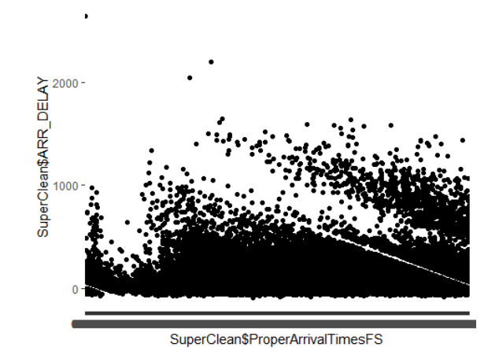

***Figure 13: Scatter plot between arrival delay and scheduled arrival time***

Figure 13 shows that arrival delays are more common in the later hours of the day. This is evidenced by the steep jump from the bottom of the x-axis to the top of the y-axis as we move to the right of the graph. It should also be noted that a similar phenomenon happens at the beginning of the scatter plot. This represents a scheduled arrival time of 00:min and confirms that arrival delays tend to happen at night. An analysis of why this occurs is outside the scope of this research study, but plausible reasons include weather, fatigue, domino effect from morning delays, and congestion as travelers tend to be out after a certain hour.

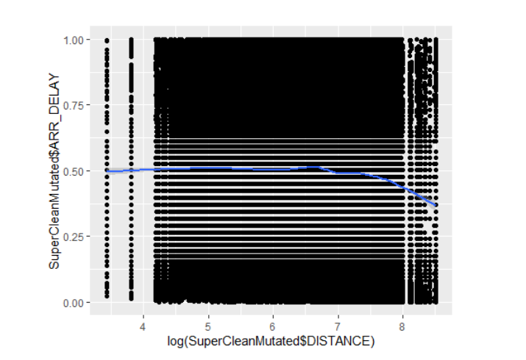

***Figure 14: Scatter plot between arrival delay and log(distance)***

Figure 14 has a line of best fit, which was helpful in explaining the relationship between arrival delay and distance. We can see from the line that there is no clear relationship between the two up until we get to a certain distance. After a long distance, the line of best fit trends downwards, indicating that as distance of flights increase, the likelihood of arrival delays decreases. Similar to the relationship between scheduled arrival and arrival delay, this relationship is outside the scope of our research study, but plausible reasons could be aircraft efficiency, as aircrafts on longer flights are permitted to fly at higher altitudes, allowing them to reach more optimal levels of speed.

**Methods:**

To determine the most accurate and robust model for predicting arrival delays, we employed three prominent machine learning techniques: Multiple Linear Regression (MLR), Random Forest Tree, and XGBoost. Each technique offers distinct advantages and has been widely used in the field of predictive modeling.

*1. Multiple Linear Regression (MLR):*

MLR is a classical statistical modeling technique used to predict a dependent variable based on multiple independent variables. In this context, MLR can be utilized to build a regression model that predicts arrival delay time using various features from the dataset, such as departure delay, airtime, distance, and carrier-specific delays. MLR provides interpretable coefficients that indicate the impact of each independent variable on the predicted outcome.

*2. Random Forest Tree:*

Random Forest is an ensemble learning technique that combines multiple decision trees to create a robust predictive model. It is well-suited for complex datasets with nonlinear relationships between variables. In our study, Random Forest Tree can be employed to generate a predictive model by constructing multiple decision trees using different subsets of the dataset. The ensemble of decision trees aggregates predictions to achieve a more accurate and stable arrival delay prediction.

*3. XGBoost:*

XGBoost is an advanced gradient boosting algorithm that has gained popularity in various machine learning competitions due to its exceptional performance. It constructs an ensemble of weak prediction models in a sequential manner, each model learning from the mistakes of its predecessors. XGBoost is known for its ability to handle complex relationships and feature interactions effectively. By leveraging XGBoost, we can develop a powerful model that optimizes the prediction of arrival delay times.

The primary research question addressed in this study is: "Which machine learning technique, among Multiple Linear Regression (MLR), Random Forest Tree, and XGBoost, would provide the most accurate and robust model for predicting arrival delays in air travel?"

To compare the performance of these techniques, we will follow a standardized methodology. The dataset will be divided into training and testing subsets to evaluate the models' performance on unseen data. Various evaluation metrics, such as root mean squared error (RMSE), and R-squared, will be used to assess the accuracy and robustness of each model.

By comparing the performance metrics and analyzing the strengths and weaknesses of each technique, we aim to identify the most accurate and robust model for predicting arrival delays in air travel. The results of this analysis will contribute valuable insights into selecting an appropriate machine learning approach for effective arrival delay prediction, aiding airlines, passengers, and stakeholders in enhancing operational efficiency and customer satisfaction in the aviation industry.

**Experiment:**

To ensure the suitability of the dataset for our experimental analysis, we conducted a thorough assessment of its compatibility with the requirements of each method employed in this study. The dataset obtained from Kaggle includes all the necessary attributes for the application of Multiple Linear Regression (MLR), Random Forest Tree, and XGBoost. These attributes encompass flight-specific information, such as departure time, departure delay, arrival time, arrival delay, airtime, distance, and various delay components (carrier delay, weather delay, NAS delay, security delay, and late aircraft delay). The dataset fulfills the requirements of each method, allowing us to proceed with the experimental setup.

In order to ensure the accuracy and validity of our regression models, some data cleaning was implemented onto the original dataset. The dataset was preprocessed to handle missing values, outliers, and categorical variables, using appropriate techniques such as imputation. Notably, the dataset lacked a scheduled departure and arrival times, which needed to be computed from DEP_TIME, ARR_TIME, ARR_DELAY, and DEP_DELAY. Since DEP_TIME and ARR_TIME were both in the hhmm format, we needed to convert these time stamps to minutes, and the make a conversion to proper 24hr hh:mm format. By doing this, we were able to accurately see the extent our the delays involved in our initial dataset. It was also apparent that several columns had over 85% blank values. This includes CARRIER_DELAY, WEATHER_DELAY, SECURITY_DELAY, NAS_DELAY, LATE_AIRCRAFT_DELAY, SECURITY_DELAY where a blank value indicates that the event never happened. To rectify this, these values were converted to 0 in order to maintain data integrity. There were also ~1100 columns where DEP_DELAY, DEP_TIME, and ARR_DELAY had ‘NA’ values. These were removed entirely from the analysis as keeping them would have severely skewed our data and models.

For Multiple Linear Regression, the dataset was split into a training set (70% of the data) and a testing set (30% of the data). This was done using the library ‘carets’, where the createDataPartition method was used to split our initial dataset into training and testing sets. The target variable for our training sets was deemed to be ARR_DELAY, while our testing set included all other column values. A linear regression model was then created using the lm() method in R, where we compared our ‘ytrain’ dataset, containing only ARR_DELAY data to our ‘xtrain’ dataset, containing all of our independent variables. The training and testing datasets containing the independent variables were then converted to factors for our prediction model. The prediction model was done using the predict() method where we fitted our MLR model onto our testing set using the selected independent variables. The model's performance was evaluated on the testing set using evaluation metrics such as root mean squared error (RMSE), and R-squared.

For the Random Forest model, the dataset was split into a testing set (66% of the data) and a training set (34% of the data). This was done using the ceiling() function in R, where we passed the argument as 66% of all rows in the initial dataset and the remaining into the training set. We then used the randomForest library in R and extracted the target variable, ARR_DELAY, from the trained data set. This was used in the randomForest() method, where we had 100 trees containing randomized dataset values from the other independent variables. A prediction model was placed on the testing data and an accuracy scored was calculated. We then calculated the root mean squared error.

For the XGBoost model, we used the exact same training and testing subsets found in the Random Forest model. However, XGBoost model was built in a sequential manner, iteratively improving upon the previous models by learning from their mistakes. Parameter tuning was performed to optimize the model's performance. One key difference was to make the flight date numeric for the XGBoost model, as there were compatibility issues if the date was kept as a time format. The xgboost library was used to run the XGBoost model with 500 rounds. This allowed for more precision as we increased the number of rounds, improving the accuracy and stability of the model. While parameter tuning, a split threshold was introduced where values above 1 fell into one node and values below 1 fell into another node. We then converted the predicted probabilities to predicted classes, and used this information for figure out an accuracy score and root mean squared error.

The performance of each method was assessed using appropriate evaluation metrics, allowing for a comprehensive comparison of their accuracy and robustness in predicting arrival delays.By following the outlined experimental setup, we can effectively assess the performance of Multiple Linear Regression, Random Forest Tree, and XGBoost on the dataset, and provide insights into the most suitable method for accurate and robust arrival delay prediction in the aviation industry.

**Results:**

*MLR:*

To begin our Multiple Linear Regression(MLR), we first performed a linear regression model between our trained subset containing the target value and our trained subset containing the independent values. The speed of the test was deemed to be a moderate speed

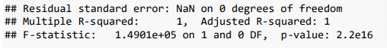

***Figure 15: Linear Regression Model between trained subset with ARR_DELAY variable and trained subset with independent variables***

From the results of the standard linear regression model, we have a R-Squared value of 1, and F-statistic of 1.4901e05, and a p-value of 2.2e16. This indicates that there is not enough evidence to suggest that the independent variables play big factors into predicting arrival delays. As a result, the prediction placed on the testing dataset was close to the initial dataset values of ARR_DELAY.

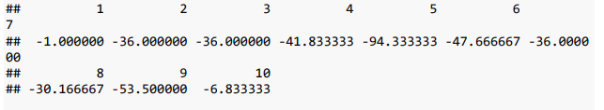

***Figure 16: MLR Prediction values for arrival delay based on linear regression model in Figure 1***

The R-squared value of our predictions, and ultimately the multiple linear regression model, came our to 0.2173564, which indicates a poor trend between the independent variables in the testing set and the prediction values from the regression model. The root mean squared error was 246.0989, which indicates significant overfitting in terms of the prediction values deviating from the actual values.

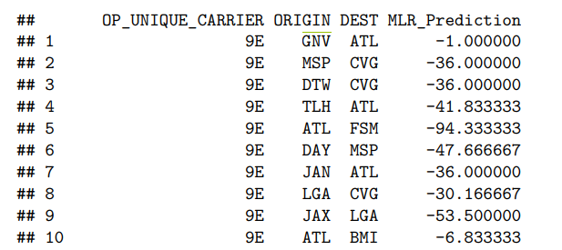

***Figure 17: MLR Prediction values from Figure 2 with origin and destination airport included.***

The prediction results above show that an Endeavor Air flight on any given day from Gainesville, FL to Atlanta, GA would arrive 1 minute early. Similarly, a flight from Minneapolis, MN to Cincinnati, OH on any given day would arrive 36mins early, and a flight from Detroit, MI to Cincinnati, OH would also arrive 36mins early. In the table above, one would only see negative values, but this is because the code reflects the first 10 flights only. In total, this model predicted more early arrivals than late arrivals, with 67% of predictions predicting flights arriving early instead of later.

*Random Forest:*

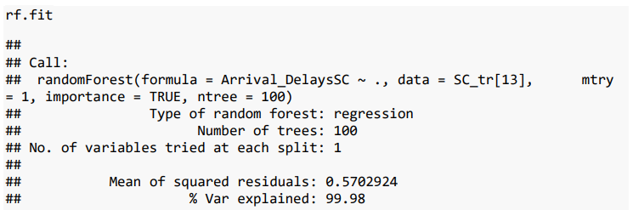

***Figure 18: Random Forest regression fit model code and results.***

The random forest model was the slowest model computationally, taking about 5-7mins to run. Our random forest fit model resulted in a Mean of Squared Residuals of 0.5702 with 99.8% variation explained by the fit model. The random forest prediction model had an R-squared value of 0.1551818, indicating a poor trend between our independent and target variables in the model. The root mean squared error was calculated to be 1.44102, which indicates slight overfitting of predicted values in comparison to actual values

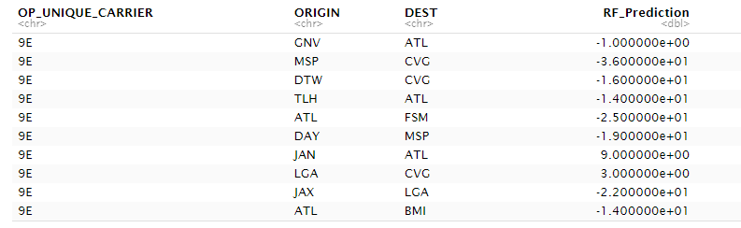

***Figure 19: Random Forest Predictions for arrival delay with origin and destination airport included.***

From our predictions above, we see the same estimation results for our Gainesville to Atlanta flight and Minneapolis to Cincinnati flight as we did in MLR. However, our flight from Detroit to Cincinnati resulted in a 20mins later arrival time than MLR. We also see positive values for the flight between Jackson, MS and Atlanta, indicating that this flight would be delayed by 9mins on any given day. The same flight for MLR was deemed to be 36mins early, demonstrating the strong variance and discrepancy in results between MLR and Random Forest. Random Forest produced 64% of predictions arriving early whereas MLR produced 36% early.

*XGBoost:*

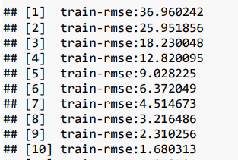

***Figure 20: Root mean squared errors for each round of XGBoost.***

Based on the classifier data from the xgboost() function, we can see that as the number of rounds increase, the root mean squared error for the model on our trained dataset significantly decreases. The metric used to evaluate the model's performance is the root mean squared error (RMSE) on the training data. In the beginning (rounds 1-10), the RMSE is relatively high, indicating that the model's predictions have a large error compared to the actual values. As the number of rounds increases, the RMSE gradually decreases, suggesting that the model is improving its ability to fit the training data.

The RMSE continues to decrease until round 500, where it reaches a very low value of 0.006988. This indicates that the model has learned to make highly accurate predictions on the training data, as the difference between the predicted values and the actual values is minimal.

The decreasing trend in RMSE occurs because XGBoost is an iterative algorithm that tries to minimize the difference between the predicted and actual values at each round. It achieves this by updating the model's parameters based on the errors made in the previous rounds.

The XGB Boost model was by far the fastest, only taking 2 minutes. The model demonstrated a R-Squared value of 0.348169 and an RMSE of 0.6759. While the R-squared is still demonstrating a poor relationship between independent variables and targe variable ARR_DELAY, the RMSE value indicates a much stronger predictive fit between prediction values from the model to actual values in the test subset.

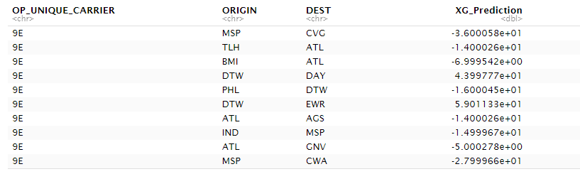

***Figure 21: XGBoost for arrival delay with origin and destination airport included***

From the predictions above, we see that the flight from Minneapolis to Cincinnati has a prediction of 36 mins early, similar to what was found in MLR and Random Forest. We can also see the that flight from Tallahassee, FL to Atlanta was predicted to come 14mins early, which is in line with Random Forest but differs largely from MLR, where that flight was predicted to arrive 41mins early. The difference in flights can be explained by the experimental procedure to predict flights onto the test subset instead of initial dataset, which occurred due to constraints of the xgbooost() function when it comes to handling datasets of different sizes. XGBoost predicted 64% of flights to arrive early, while 36% to arrive late, which is similar to the distribution seen in Random Forest.

**Conclusion:**

In this study, we compared the performance of three regression models, namely Multiple Linear Regression (MLR), Random Forest, and XGBoost, for predicting flight arrival delays. The goal was to determine which model would create the most robust and accurate predictions.

Starting with MLR, the results showed that the independent variables had little influence on predicting arrival delays, as indicated by the R-squared value of 0.2173564. The model suffered from significant overfitting, with a root mean squared error (RMSE) of 246.0989, implying a large deviation between predicted and actual values. The predictions from MLR indicated that flights were more likely to arrive early rather than late, with 67% of predictions suggesting early arrivals.

Moving on to Random Forest, the model demonstrated better performance than MLR. The Mean Squared Residuals of 0.5702 and 99.8% variation explained by the fit model indicated a relatively good fit. However, the R-squared value of 0.1551818 indicated a poor trend between the independent variables and the target variable. The RMSE of 1.44102 suggested slight overfitting. The predictions from Random Forest showed some discrepancies compared to MLR, but still predicted more early arrivals (64%) than late arrivals.

Finally, the XGBoost model outperformed both MLR and Random Forest in terms of computational speed, while also achieving a better predictive performance. The decreasing trend in the RMSE during the training process indicated that the model improved its ability to fit the training data. The XGBoost model demonstrated an R-squared value of 0.348169 and an RMSE of 0.6759. Although the R-squared value indicated a poor relationship between the independent variables and arrival delays, the RMSE suggested a stronger predictive fit. The predictions from XGBoost showed similarities to Random Forest, with 64% of flights predicted to arrive early and 36% predicted to arrive late.

Based on the results, it can be concluded that XGBoost performed the best among the three models in terms of predictive accuracy. Despite the poor relationship between the independent variables and the target variable (as indicated by R-squared), XGBoost managed to make more accurate predictions, as evidenced by the lower RMSE compared to MLR and Random Forest. The ability of XGBoost to capture complex patterns and relationships within the data contributed to its superior performance.

The subpar results observed in all three models can be attributed to various factors. Firstly, the selected independent variables may not capture all the relevant features that influence flight arrival delays. Secondly, the inherent complexity and nonlinearity of the relationship between the independent variables and the target variable may require more advanced modeling techniques, such as neural networks or deep learning, to achieve better predictive accuracy. We can also attribute these results to computational limits on how much data can be processed. While the intention was to look at flight data from an entire calendar year, handling this much data in Excel and R proved to be a arduous task- one that could not be completed on a standard PC. When downloading data from Kaggle to Excel, Excel put a cap at 1,048,576 rows of data. As a result, the data analyzed came only from the months of January and February of 2019, which heavily skewed our analysis and limited our models capabilities in accurately predicting arrival delays.

To improve the quality of the models and achieve the goal of determining the most robust and accurate regression model for predicting flight arrival delays, two specific steps can be taken: utilizing the bootstrapping technique in Random Forest and performing hyperparameter tuning in XGBoost.

*1. Bootstrapping in Random Forest:*

Random Forest is an ensemble learning method that combines multiple decision trees to make predictions. One way to enhance the performance of Random Forest is by employing bootstrapping, a resampling technique. Bootstrapping involves creating multiple training datasets by randomly sampling the original dataset with replacement. Each dataset is then used to train a separate decision tree in the Random Forest.

By incorporating bootstrapping, Random Forest can generate diverse and robust decision trees. These trees will have variations in their training data, leading to different splits and predictions. Combining the predictions from multiple diverse trees reduces the risk of overfitting and enhances the model's generalization capabilities. Consequently, the overall performance of Random Forest is likely to improve, resulting in more accurate predictions of flight arrival delays.

*2. Hyperparameter tuning in XGBoost:*

XGBoost is an advanced gradient boosting algorithm that combines weak learners to create a strong predictive model. It consists of several hyperparameters that control the behavior and performance of the algorithm. To optimize the performance of XGBoost, hyperparameter tuning is essential.

Hyperparameter tuning involves systematically searching and selecting the best combination of hyperparameters for the XGBoost model. This process can be done using techniques such as grid search, random search, or Bayesian optimization. By exploring different hyperparameter configurations, we can find the set of values that maximizes the model's performance on the given dataset.

Optimizing the hyperparameters of XGBoost can lead to significant improvements in the model's predictive accuracy. It allows the algorithm to adapt better to the specific characteristics of the flight arrival delay prediction task, resulting in a more robust and accurate model. By fine-tuning hyperparameters such as the learning rate, maximum tree depth, and regularization parameters, we can enhance the model's ability to capture complex relationships and generalize well to unseen data.

By incorporating bootstrapping in Random Forest and performing hyperparameter tuning in XGBoost, we address specific weaknesses and limitations of the respective models. These steps aim to improve the models' performance by reducing overfitting, increasing diversity in predictions, and optimizing the algorithm's behavior to better suit the given prediction task. Ultimately, these enhancements contribute to our goal of identifying the most robust and accurate regression model for predicting flight arrival delays.

In conclusion, among the three models compared, XGBoost demonstrated the most robust and accurate predictions of flight arrival delays. However, the subpar performance of all three models highlights the complexity of predicting flight delays and the need for further research and feature engineering to capture the underlying factors affecting arrival times. Improvements can be made by incorporating additional relevant features and exploring more advanced modeling techniques.

**Citations:**

Data Source:

<https://www.kaggle.com/datasets/sherrytp/airline-delay-analysis>

Project Inspiration:

<https://medium.com/swlh/flight-delay-analysis-with-random-forest-and-xgboost-e3357b0fdea2>

XGBoost assistance:

<https://medium.com/swlh/flight-delay-analysis-with-random-forest-and-xgboost-e3357b0fdea2>

Yinghan Wu, Gang Mei, Kaixuan Shao,Revealing influence of meteorological conditions and flight factors on delays Using XGBoost, Journal of Computational Mathematics and Data Science, Volume 3, 2022, 100030, ISSN 2772-4158, https://doi.org/10.1016/j.jcmds.2022.100030.

MLR Assistance:

Vandal, T., Livingston, M., Piho, C. &amp; Zimmerman, S.. (2018). Prediction and Uncertainty Quantification of Daily Airport Flight Delays. <i>Proceedings of The 4th International Conference on Predictive Applications and APIs</i>, in <i>Proceedings of Machine Learning Research</i> 82:45-51 Available from https://proceedings.mlr.press/v82/vandal18a.html.

Ding, Yi. (2017). Predicting flight delay based on multiple linear regression. IOP Conference Series: Earth and Environmental Science. 81. 012198. 10.1088/1755-1315/81/1/012198.

Random Forest Assistance:

<https://gist.github.com/yanniey/66a937cacf777c4b4e8a58aff43117e6>

P. Hu, J. Zhang and N. Li, "Research on Flight Delay Prediction Based on Random Forest," 2021 IEEE 3rd International Conference on Civil Aviation Safety and Information Technology (ICCASIT), Changsha, China, 2021, pp. 506-509, doi: 10.1109/ICCASIT53235.2021.9633476.

<https://scholarworks.calstate.edu/downloads/qr46r081g>

Busiest Airports in USA:

[*"CY 2021 Commercial Service Airports, Rank Order"*](https://www.faa.gov/sites/faa.gov/files/2022-09/cy21-commercial-service-enplanements.pdf) *(PDF)*. Federal Aviation Administration. 2022-09-16. [*Archived*](https://web.archive.org/web/20230203221726/https:/www.faa.gov/sites/faa.gov/files/2022-09/cy21-commercial-service-enplanements.pdf) *(PDF)* from the original on 2023-02-03*. Retrieved 2023-02-03*.